Welcome to
Mt. Hope Lutheran Church
Lutheran Church—Missouri Synod
905 N I-75
Business Loop
Grayling, Michigan

(989) 348-5921

Web: mthopelcmsgrayling.org

September 18, 2022
Fifteenth Sunday after Pentecost
Preacher: Rev. Ken Bernthal

ABOUT OUR WORSHIP
We welcome all who gather here today! We are blessed to celebrate together the mercy, grace, and love we have from God through the death and resurrection of our Lord Jesus Christ.

Children: Families with children are very welcome here. Having children in church is important so they can begin to learn about their faith in Jesus, and it’s good for the whole congregation to see. Please feel comfortable keeping “squirmy” kids in the service. This is where they belong, too!

Pew Cards: Guests and Members, please fill out the Guest/Member card located on the back of the pew in front of you and pass it to the end of the aisle. If you forget you can put it in the offering plate on your way out.

If standing is difficult: Please feel free to remain seated during any portion of the service. Please let an Elder or Usher know if you need communion in your pew seat.

About our celebration of Holy Communion: We celebrate the Lord’s Supper in the confession and glad confidence that, as he says, our Lord gives into our mouths not only bread and wine but his very body and blood to eat and to drink for the forgiveness of sins and to strengthen our union with him and with one another. Our Lord invites to his table those who trust his words, repent of all sin, and set aside any refusal to forgive and love as he forgives and loves us, that they may show forth his death until he comes.

Because those who eat and drink our Lord’s body and blood contrary to that which is stated above do so to their great harm, and also because Holy Communion is a confession of the faith which is confessed at this altar. Anyone who is not yet instructed, in doubt, or who hold a confession differing from that of the Lutheran Church—Missouri Synod, and yet desire to receive the sacrament, are asked first to speak with Pastor. Those not communing are still invited to come forward for a blessing from Pastor, and you may indicate this by crossing your arms over your chest.
TTTTTT
GREETING

P Peace be with you.
C And also with you.
T ORDER OF SERVICE T
(The liturgy is from Divine Service Setting four LSB pg. 203ff)

OPENING HYMN
Voices Raised to You We Offer LSB 795
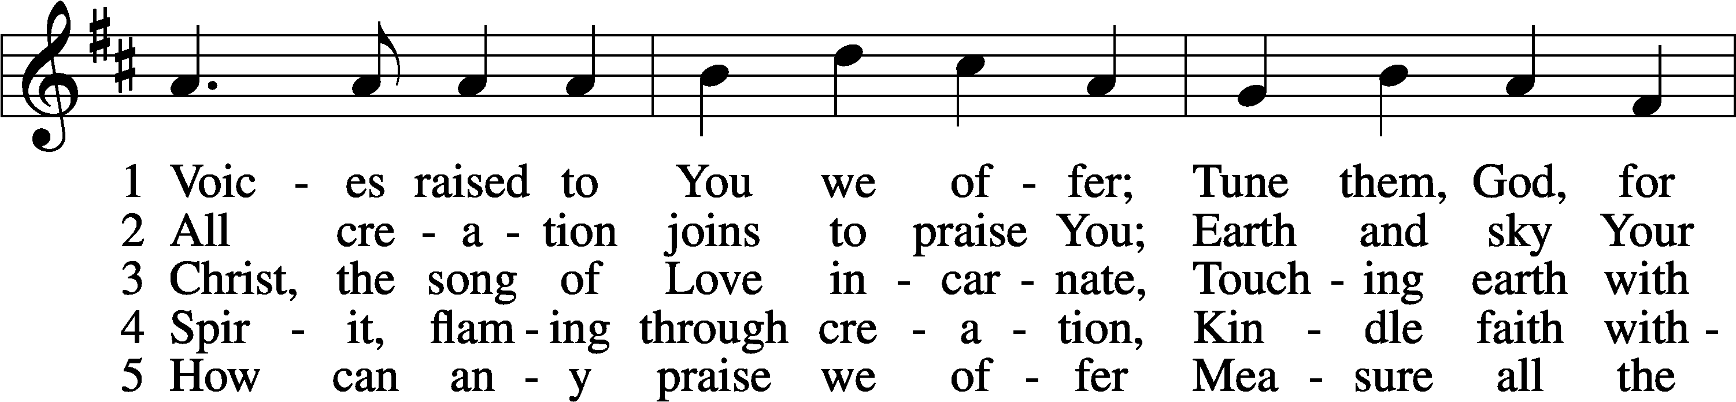
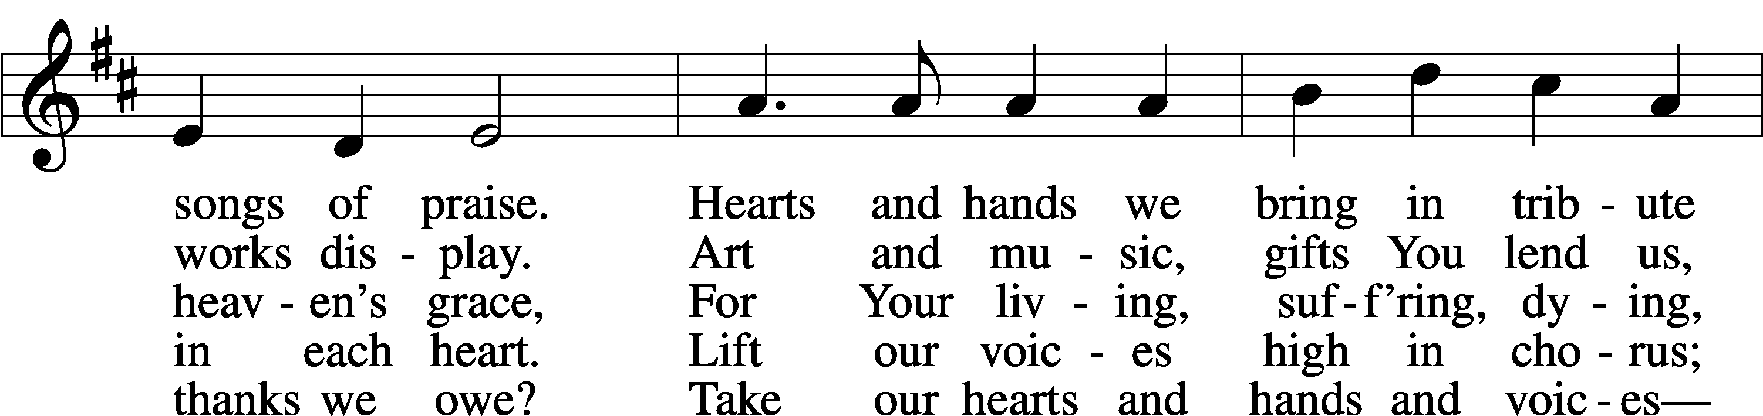
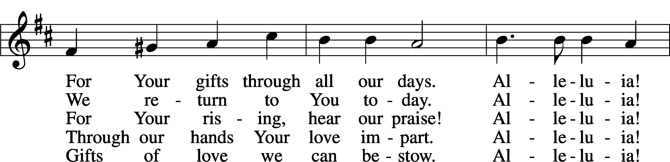
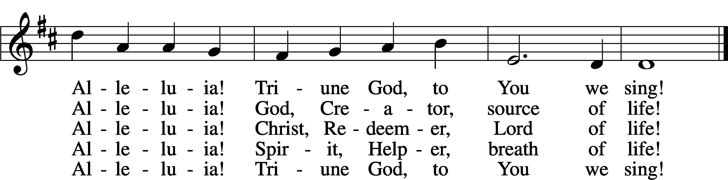
Text: Herman G. Stuempfle, Jr., 1923–2007
Tune: Carolyn Jennings, 1936
Text: © 1997 GIA Publications, Inc. Used by permission: LSB Hymn License no. 110002537
Tune: © 1996 Carolyn Jennings. Used by permission: LSB Hymn License no. 110002537

Please stand as able
CONFESSION and ABSOLUTION
The sign of the cross may be made by all in remembrance of their Baptism.
P In the name of the Father and of the T Son and of the Holy Spirit.
C Amen.
P Our help is in the name of the Lord,
C who made heaven and earth.
P If You, O Lord, kept a record of sins, O Lord, who could stand?
C But with You there is forgiveness; therefore, You are feared.
P Since we are gathered to hear God’s Word, call upon Him in prayer and praise, and receive the body and blood of our Lord Jesus Christ in the fellowship of this altar, let us first consider our unworthiness and confess before God and one another that we have sinned in thought, word, and deed, and that we cannot free ourselves from our sinful condition. Together as His people let us take refuge in the infinite mercy of God, our heavenly Father, seeking His grace for the sake of Christ, and saying: God, be merciful to me, a sinner.
C Almighty God, have mercy upon us, forgive us our sins, and lead us to everlasting life. Amen.
P Almighty God in His mercy has given His Son to die for you and for His sake forgives you all your sins. As a called and ordained servant of Christ, and by His authority, I therefore forgive you all your sins in the name of the Father and of the T Son and of the Holy Spirit.
C Amen.
SERVICE OF THE WORD
INTROIT Psalm 119:137–140, 142; antiphon: v. 144
P Your testimonies are righteous forever;
give me understanding that I may live.
C Righteous are you, O Lord,
and right are your just decrees.
P You have appointed your testimonies in righteousness
and in all faithfulness.
C My zeal consumes me,
because my foes forget your words.
P Your promise is well tried,
and your servant loves it.
C Your righteousness is righteous forever,
and your law is true.
A Glory be to the Father and to the Son
and to the Holy Spirit;
as it was in the beginning,
is now, and will be forever. Amen.
P Your testimonies are righteous forever;
give me understanding that I may live.

KYRIE LSB 204
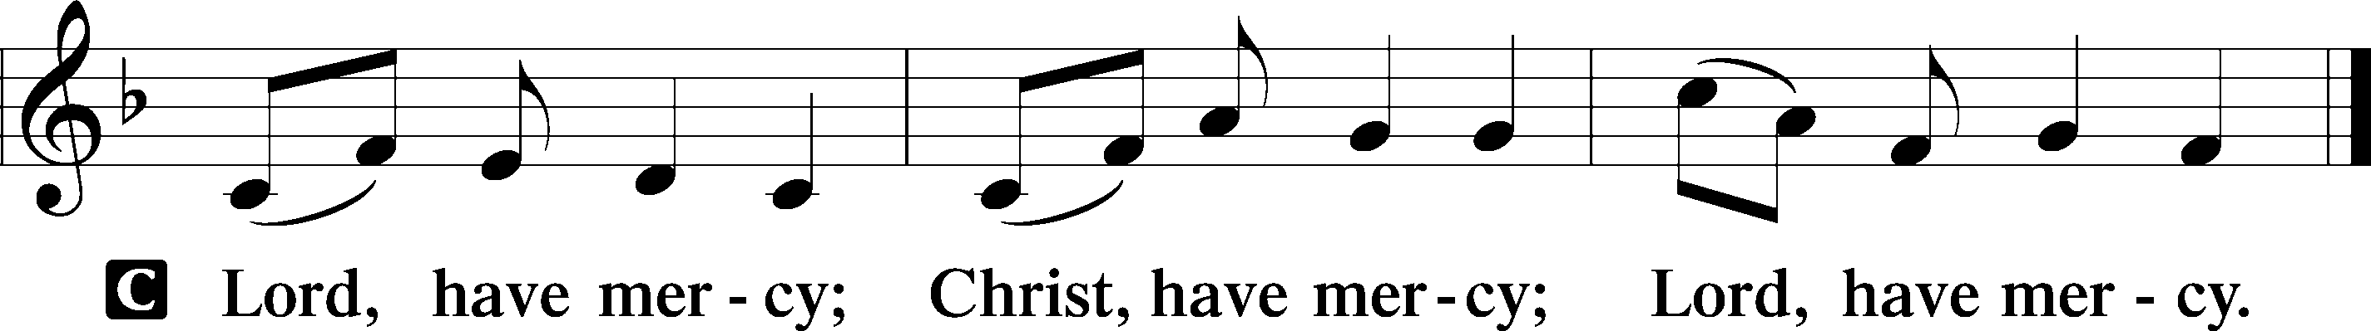

HYMN OF PRAISE
GLORIA IN EXCELSIS LSB 204
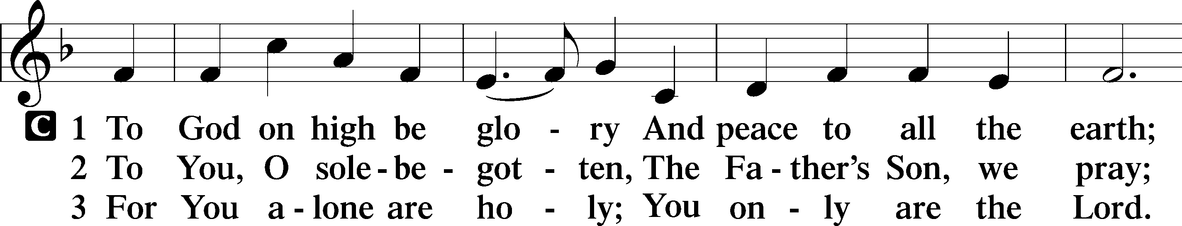
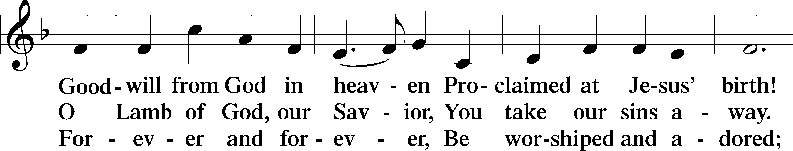
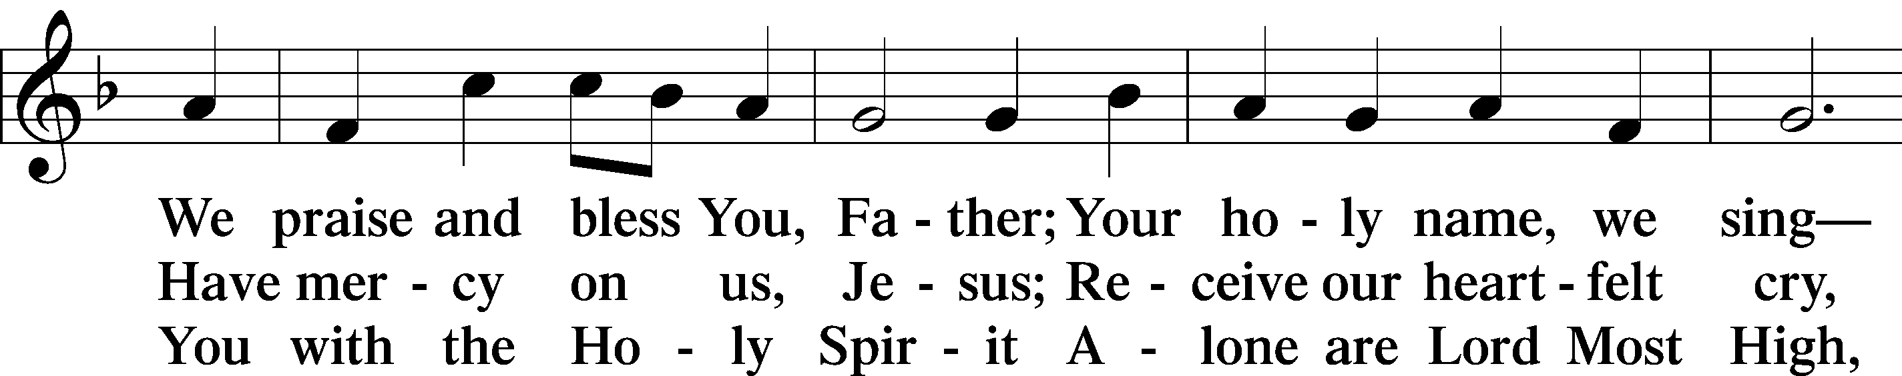
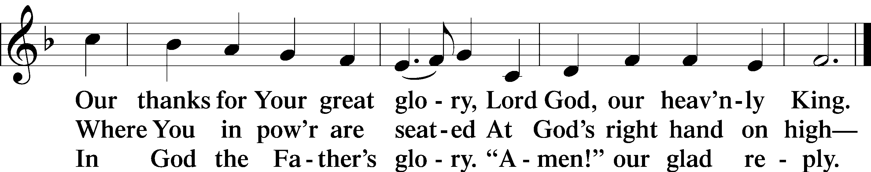
Text: Stephen P. Starke

SALUTATION AND COLLECT OF THE DAY
P The Lord be with you.
C And also with you.
P Let us pray.
O Lord, keep Your Church in Your perpetual mercy; and because without You we cannot but fall, preserve us from all things hurtful, and lead us to all things profitable to our salvation; through Jesus Christ, Your Son, our Lord, who lives and reigns with You and the Holy Spirit, one God, now and forever.
C Amen.

Please be seated

OLD TESTAMENT READING Amos 8:4–7
⁴Hear this, you who trample on the needy
and bring the poor of the land to an end,
⁵saying, “When will the new moon be over,
that we may sell grain?
And the Sabbath,
that we may offer wheat for sale,
that we may make the ephah small and the shekel great
and deal deceitfully with false balances,
⁶that we may buy the poor for silver
and the needy for a pair of sandals
and sell the chaff of the wheat?”
⁷The Lord has sworn by the pride of Jacob:
“Surely I will never forget any of their deeds.”
P This is the Word of the Lord.
C Thanks be to God.

EPISTLE 1 Timothy 2:1–15
¹First of all, then, I urge that supplications, prayers, intercessions, and thanksgivings be made for all people, ²for kings and all who are in high positions, that we may lead a peaceful and quiet life, godly and dignified in every way. ³This is good, and it is pleasing in the sight of God our Savior, ⁴who desires all people to be saved and to come to the knowledge of the truth. ⁵For there is one God, and there is one mediator between God and men, the man Christ Jesus, ⁶who gave himself as a ransom for all, which is the testimony given at the proper time. ⁷For this I was appointed a preacher and an apostle (I am telling the truth, I am not lying), a teacher of the Gentiles in faith and truth.
⁸I desire then that in every place the men should pray, lifting holy hands without anger or quarreling; ⁹likewise also that women should adorn themselves in respectable apparel, with modesty and self-control, not with braided hair and gold or pearls or costly attire, ¹⁰but with what is proper for women who profess godliness—with good works. ¹¹Let a woman learn quietly with all submissiveness. ¹²I do not permit a woman to teach or to exercise authority over a man; rather, she is to remain quiet. ¹³For Adam was formed first, then Eve; ¹⁴and Adam was not deceived, but the woman was deceived and became a transgressor. ¹⁵Yet she will be saved through childbearing—if they continue in faith and love and holiness, with self-control.

P This is the Word of the Lord.
C Thanks be to God.
Please stand as able

ALLELUIA AND VERSE
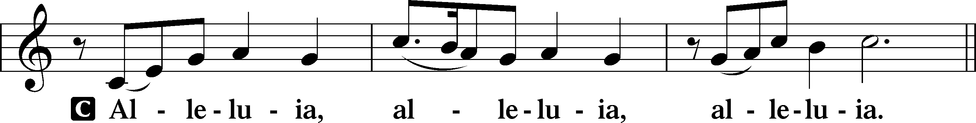
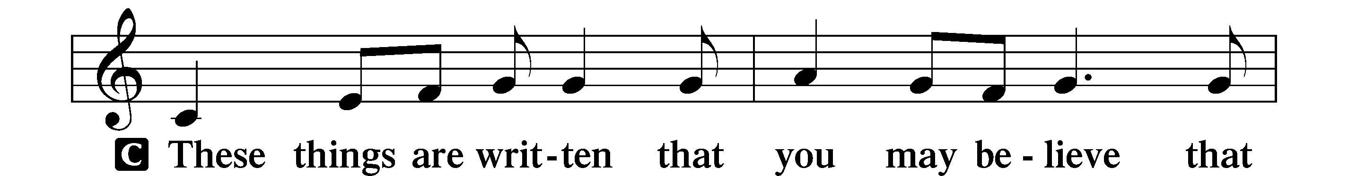

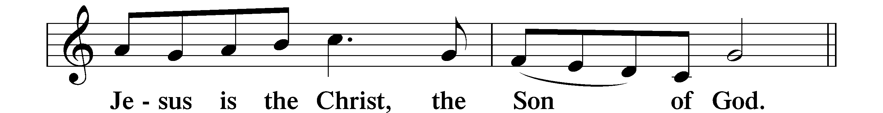
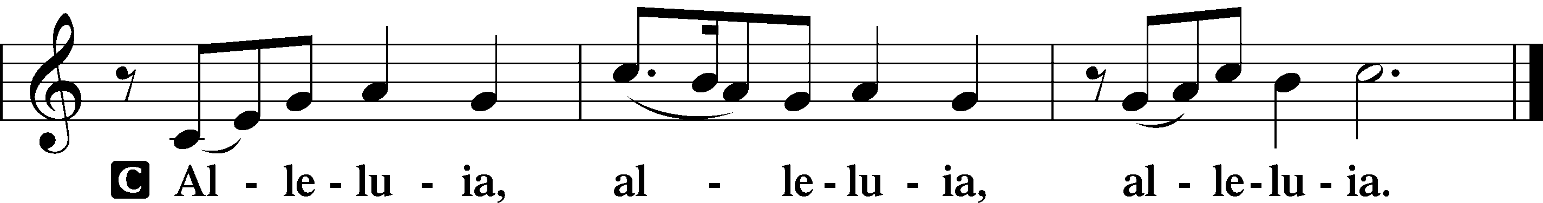

HOLY GOSPEL Luke 16:1–15
P The Holy Gospel according to St. Luke, the sixteenth chapter.
C Glory to You, O Lord.
¹[Jesus] also said to the disciples, “There was a rich man who had a manager, and charges were brought to him that this man was wasting his possessions. ²And he called him and said to him, ‘What is this that I hear about you? Turn in the account of your management, for you can no longer be manager.’ ³And the manager said to himself, ‘What shall I do, since my master is taking the management away from me? I am not strong enough to dig, and I am ashamed to beg. ⁴I have decided what to do, so that when I am removed from management, people may receive me into their houses.’ ⁵So, summoning his master’s debtors one by one, he said to the first, ‘How much do you owe my master?’ ⁶He said, ‘A hundred measures of oil.’ He said to him, ‘Take your bill, and sit down quickly and write fifty.’ ⁷Then he said to another, ‘And how much do you owe?’ He said, ‘A hundred measures of wheat.’ He said to him, ‘Take your bill, and write eighty.’ ⁸The master commended the dishonest manager for his shrewdness. For the sons of this world are more shrewd in dealing with their own generation than the sons of light. ⁹And I tell you, make friends for yourselves by means of unrighteous wealth, so that when it fails they may receive you into the eternal dwellings.
¹⁰“One who is faithful in a very little is also faithful in much, and one who is dishonest in a very little is also dishonest in much. ¹¹If then you have not been faithful in the unrighteous wealth, who will entrust to you the true riches? ¹²And if you have not been faithful in that which is another’s, who will give you that which is your own? ¹³No servant can serve two masters, for either he will hate the one and love the other, or he will be devoted to the one and despise the other. You cannot serve God and money.”
¹⁴The Pharisees, who were lovers of money, heard all these things, and they ridiculed him. ¹⁵And he said to them, “You are those who justify yourselves before men, but God knows your hearts. For what is exalted among men is an abomination in the sight of God.”

P This is the Gospel of the Lord.
C Praise to You, O Christ.

NICENE CREED
C I believe in one God,
the Father Almighty,
maker of heaven and earth
and of all things visible and invisible.
And in one Lord Jesus Christ,
the only-begotten Son of God,
begotten of His Father before all worlds,
God of God, Light of Light,
very God of very God,
begotten, not made,
being of one substance with the Father,
by whom all things were made;
who for us men and for our salvation came down from heaven
and was incarnate by the Holy Spirit of the virgin Mary
and was made man;
and was crucified also for us under Pontius Pilate.
He suffered and was buried.
And the third day He rose again according to the Scriptures
and ascended into heaven
and sits at the right hand of the Father.
And He will come again with glory to judge both the living and the dead,
whose kingdom will have no end.
And I believe in the Holy Spirit,
the Lord and giver of life,
who proceeds from the Father and the Son,
who with the Father and the Son together is worshiped and glorified,
who spoke by the prophets.
And I believe in one holy Christian and apostolic Church,
I acknowledge one Baptism for the remission of sins,
and I look for the resurrection of the dead
and the life T of the world to come. Amen.

Please be seated

SERMON HYMN
Son of God, Eternal Savior LSB 842
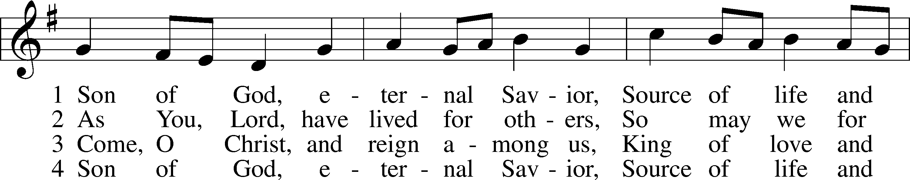
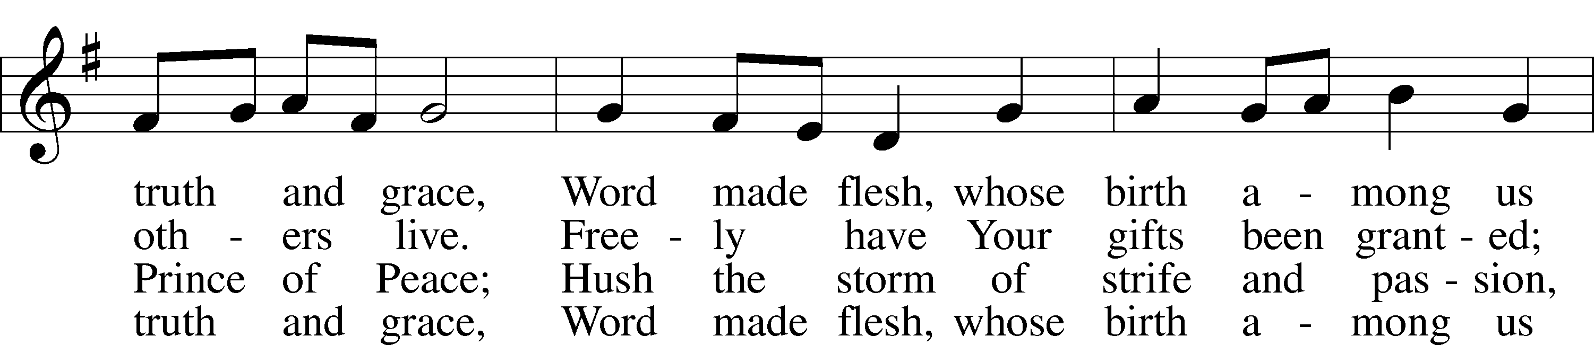

Continued on next page
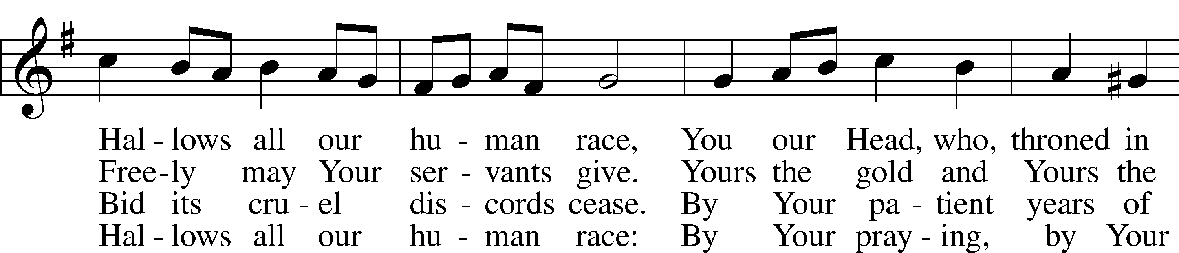
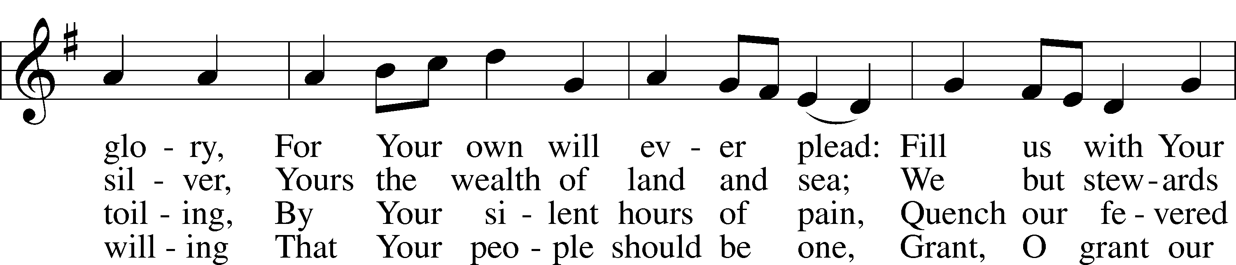
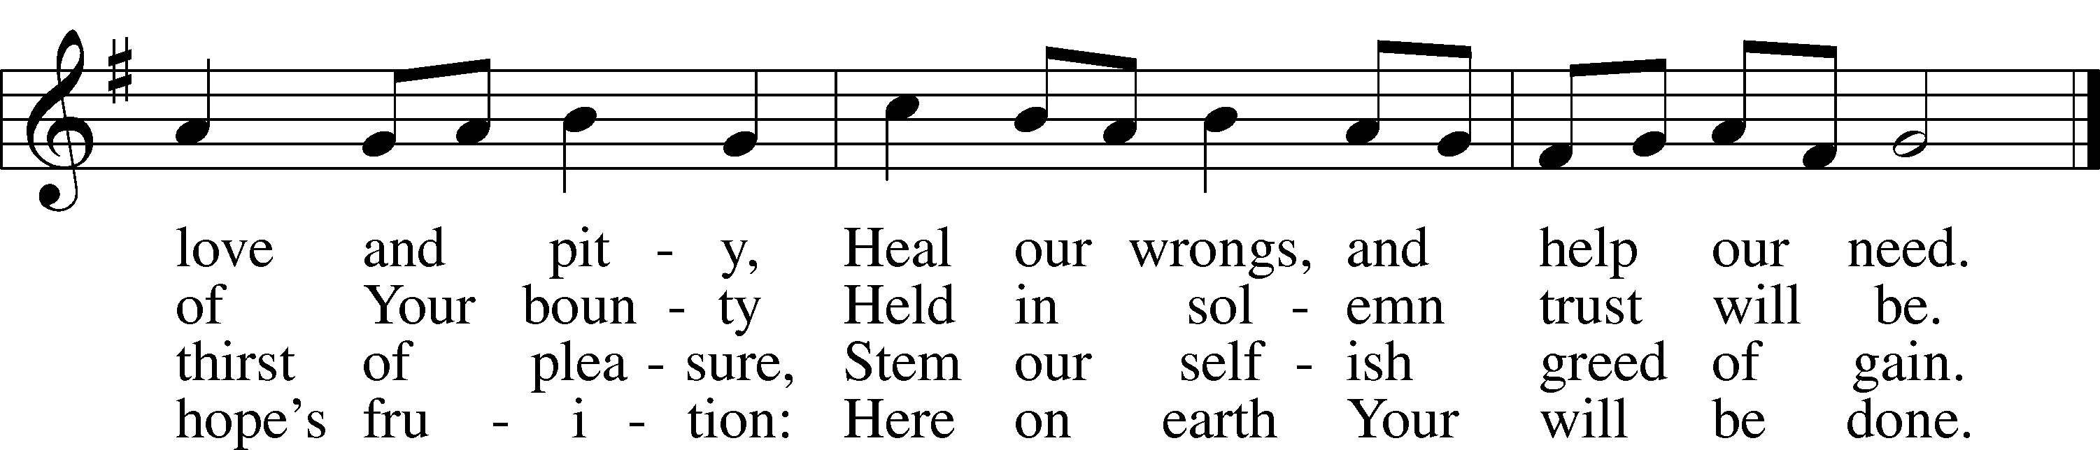

Text: Somerset T. C. Lowry, 1855–1932, alt.
Tune: Oude en Nieuwe Hollantse . . . Contradanseu, c. 1710, Amsterdam
Text and tune: Public domain

SERMON

Please stand as able

PRAYER of the CHURCH
After each Segment:
P Lord, in Your Mercy,
C Hear our Prayer.
After Final Segment:
P Hear us as we pray in His name and as He has taught us:
LORD’S PRAYER
C Our Father who art in heaven,
hallowed be Thy name,
Thy kingdom come,
Thy will be done on earth
as it is in heaven;
give us this day our daily bread;
and forgive us our trespasses
as we forgive those
who trespass against us;
and lead us not into temptation,
but deliver us from evil.
For Thine is the kingdom
and the power and the glory
forever and ever. Amen.

SERVICE of the SACRAMENT

PREFACE LSB 208
P The Lord be with you.
C And also with you.
P Lift up your hearts.
C We lift them to the Lord.
P Let us give thanks to the Lord our God.
C It is right to give Him thanks and praise.
P It is truly good, right, and salutary that we should at all times and in all places give thanks to You, O Lord, holy Father, almighty and everlasting God, for the countless blessings You so freely bestow on us and all creation. Above all, we give thanks for Your boundless love shown to us when You sent Your only-begotten Son, Jesus Christ, into our flesh and laid on Him our sin, giving Him into death that we might not die eternally. Because He is now risen from the dead and lives and reigns to all eternity, all who believe in Him will overcome sin and death and will rise again to new life. Therefore with angels and archangels and with all the company of heaven we laud and magnify Your glorious name, evermore praising You and singing:
SANCTUS LSB 208
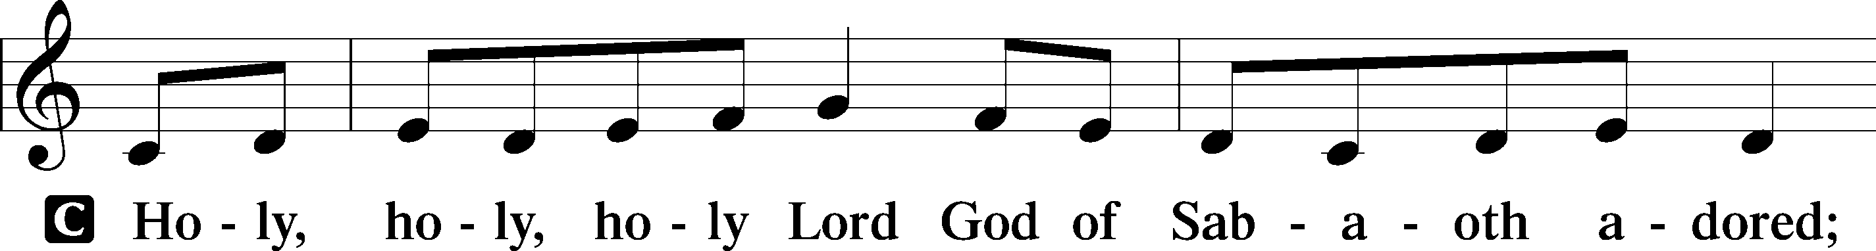

Continued on next page
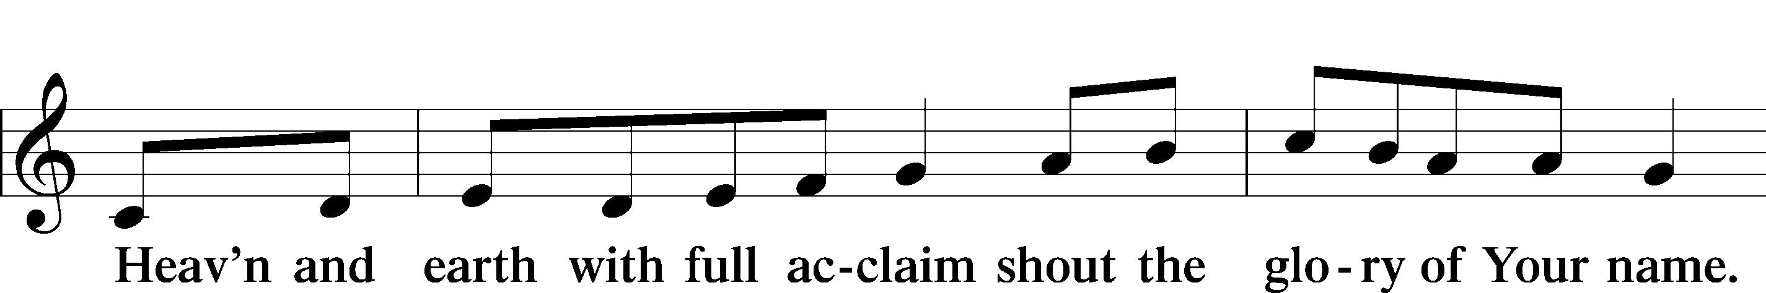
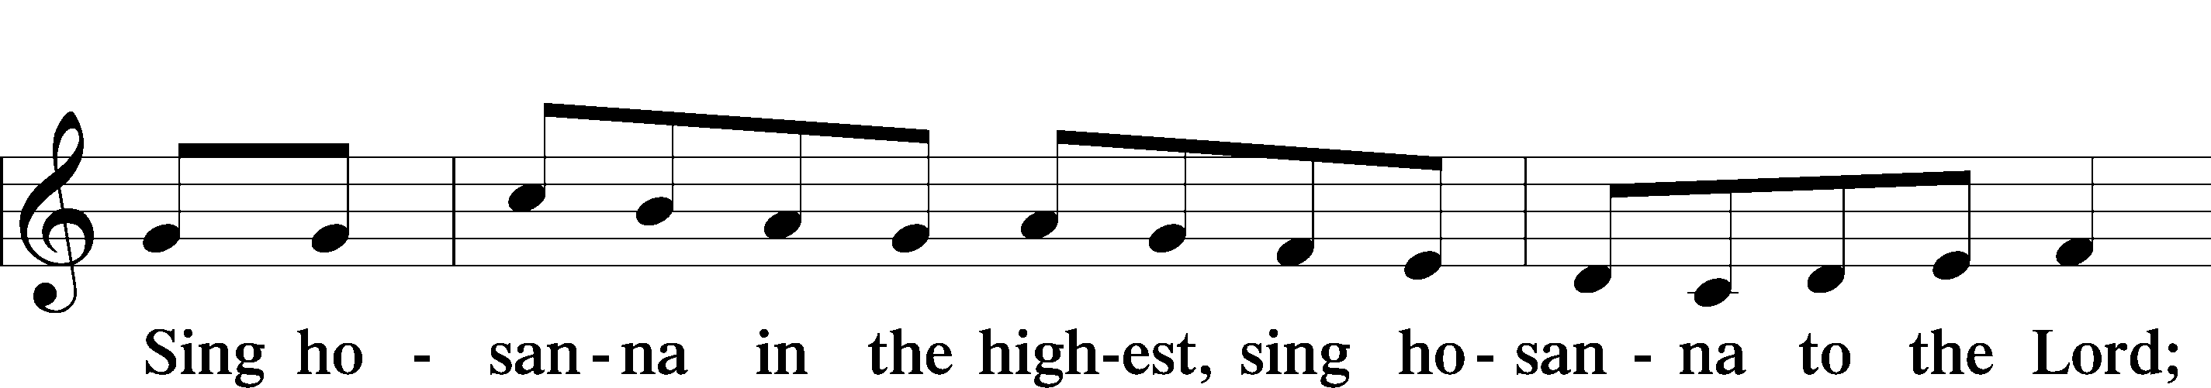

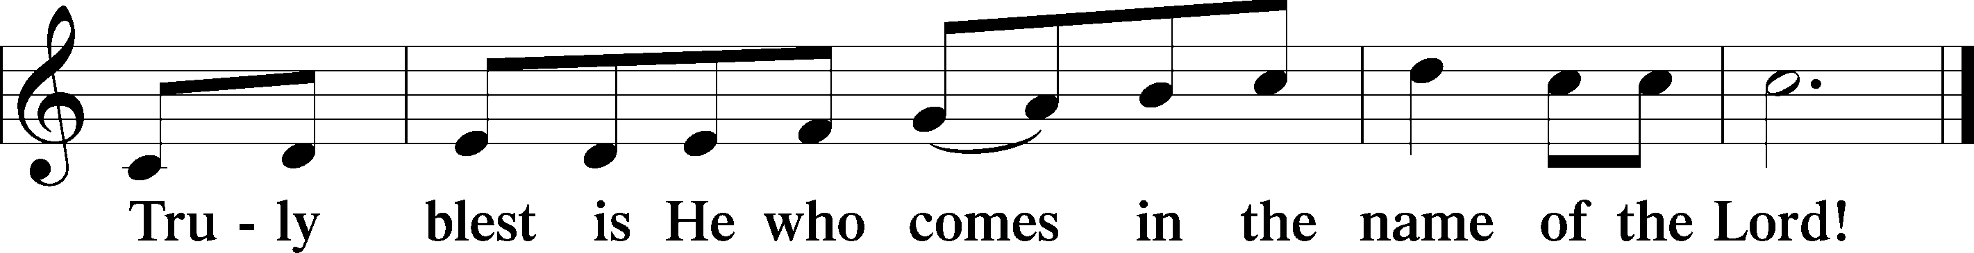

PRAYER OF THANKSGIVING
P Blessed are You, O Lord our God, king of all creation, for You have had mercy on us and given Your only-begotten Son that whoever believes in Him should not perish but have eternal life.
In Your righteous judgment You condemned the sin of Adam and Eve, who ate the forbidden fruit, and You justly barred them and all their children from the tree of life. Yet, in Your great mercy, You promised salvation by a second Adam, Your Son, Jesus Christ, our Lord, and made His cross a life-giving tree for all who trust in Him.
We give You thanks for the redemption You have prepared for us through Jesus Christ. Grant us Your Holy Spirit that we may faithfully eat and drink of the fruits of His cross and receive the blessings of forgiveness, life, and salvation that come to us in His body and blood.

THE WORDS OF OUR LORD
P Our Lord Jesus Christ, on the night when He was betrayed, took bread, and when He had given thanks, He broke it and gave it to the disciples and said: “Take, eat; this is My T body, which is given for you. This do in remembrance of Me.”
In the same way also, He took the cup after supper, and when He had given thanks, He gave it to them, saying: “Drink of it, all of you; this cup is the New Testament in My T blood, which is shed for you for the forgiveness of sins. This do, as often as you drink it, in remembrance of Me.”

PAX DOMINI
P The peace of the Lord be with you always.
C Amen.
AGNUS DEI
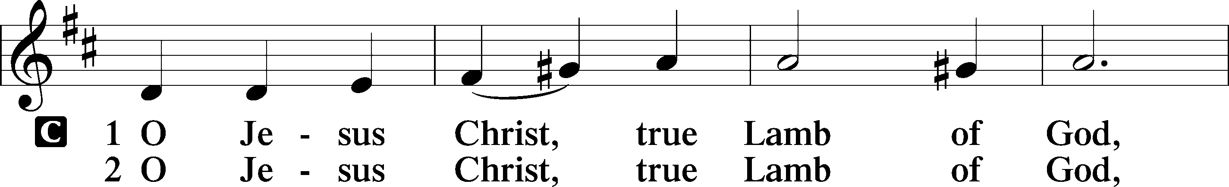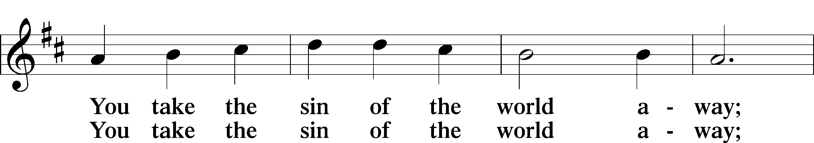
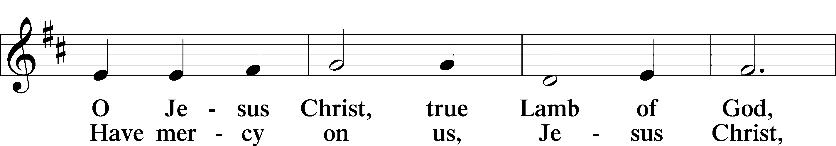
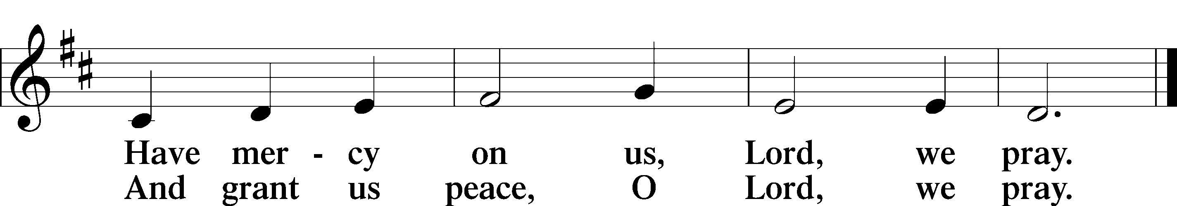

Please be seated

DISTRIBUTION
The pastor and those who assist him receive the body and blood of Christ first, then Communion will be served at the rail. Ushers will help direct you forward via the center aisle; please return to your seats via the side aisles. Gluten-free bread is available for those who need it, as is non-alcoholic grape juice. Simply request either when you come forward to receive Communion.

DISTRIBUTION HYMN

Not What These Hands Have Done LSB 567
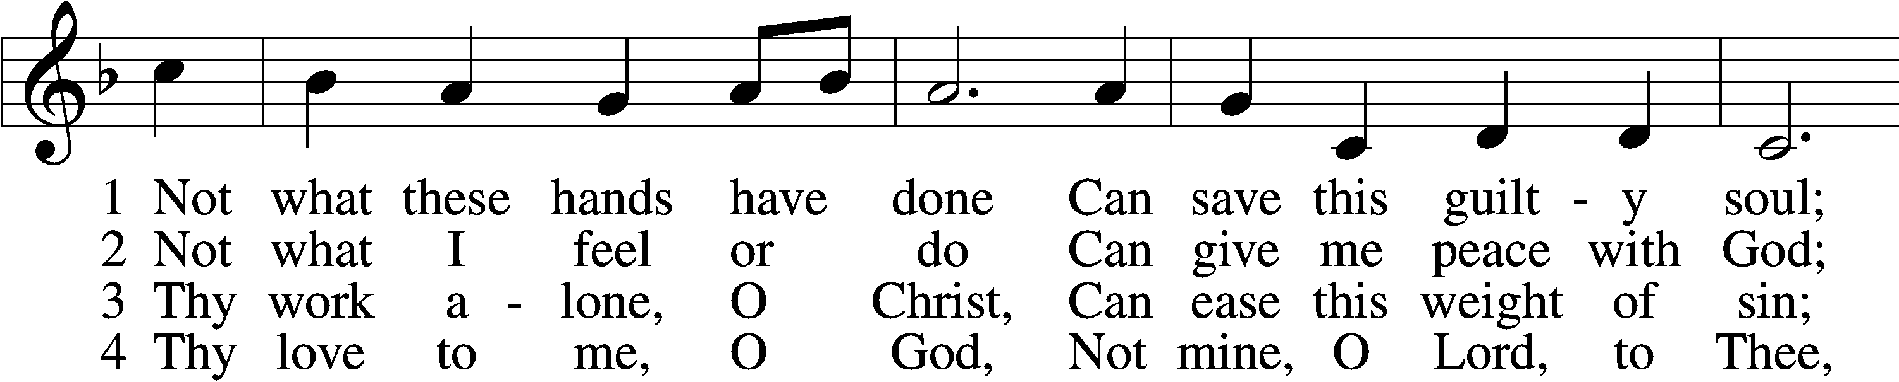
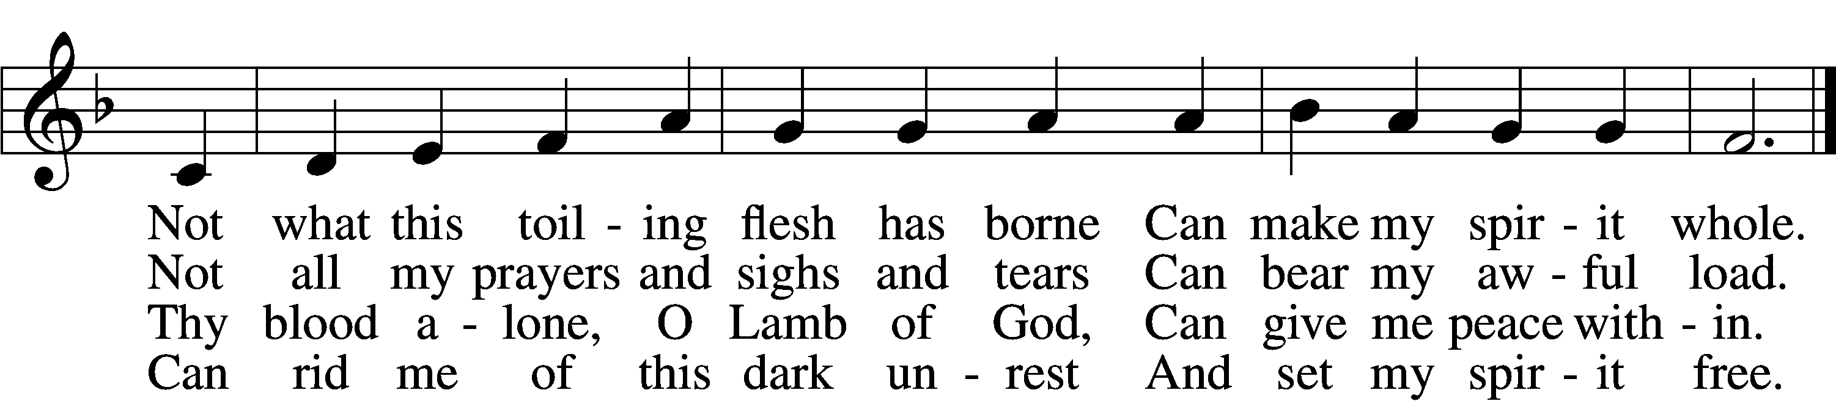

5 Thy grace alone, O God,
To me can pardon speak;
Thy pow’r alone, O Son of God,
Can this sore bondage break. .

6 I bless the Christ of God,
I rest on love divine,
And with unfalt’ring lip and heart
I call this Savior mine.
Text: Horatius Bonar, 1808–89
Tune: William H. Monk, 1823–89
Text and tune: Public domain

Please stand as able

NUNC DIMITTIS LSB 211
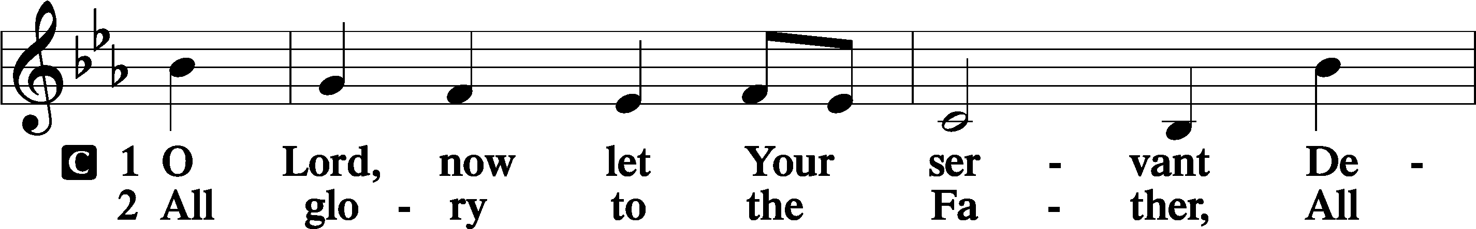
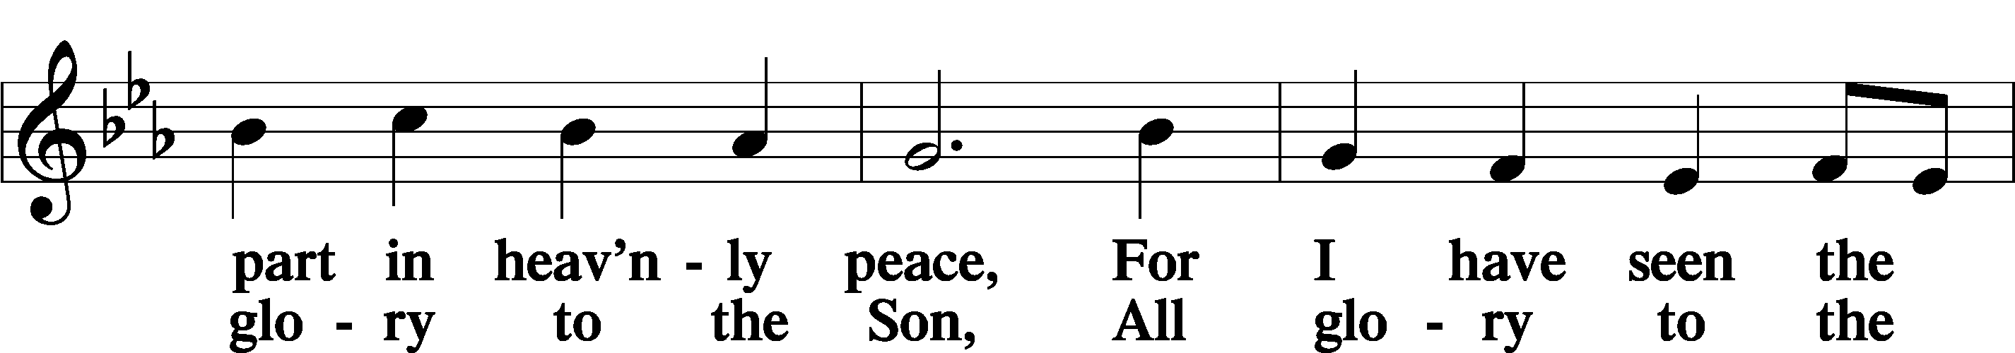
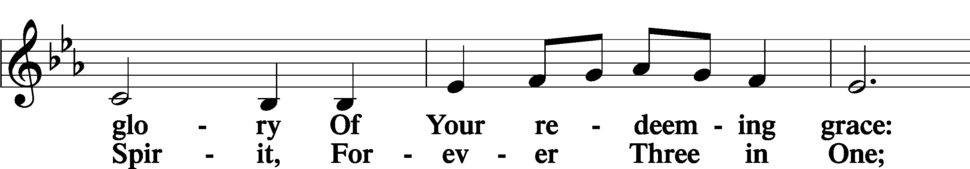
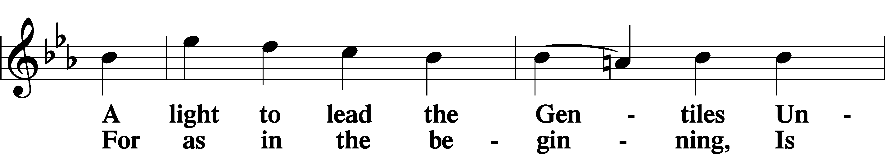
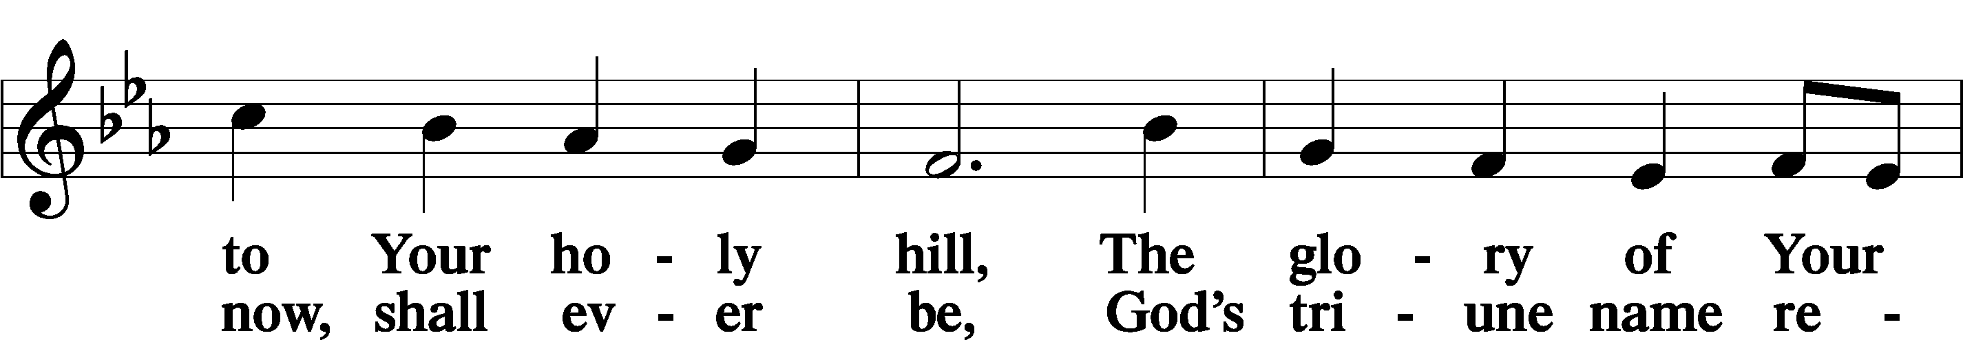
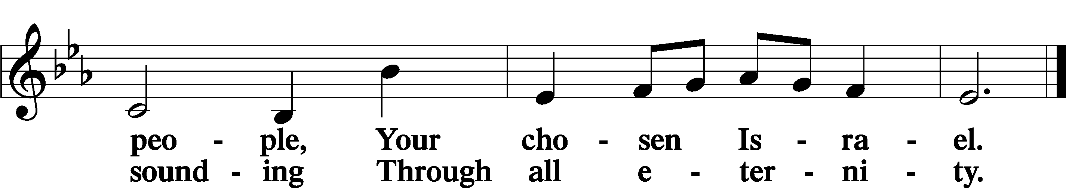

POST COMMUNION COLLECT
P Let us pray.
We give thanks to You, almighty God, that You have refreshed us through this salutary gift, and we implore You that of Your mercy You would strengthen us through the same in faith toward You and in fervent love toward one another; through Jesus Christ, Your Son, our Lord, who lives and reigns with You and the Holy Spirit, one God, now and forever.
C Amen.

BENEDICAMUS LSB 212
P Let us bless the Lord.
C Thanks be to God.
BENEDICTION
P The Lord bless you and keep you.
The Lord make His face shine on you and be gracious to you.
The Lord look upon you with favor and T give you peace.
C Amen.

Please be seated
CLOSING HYMN
Before You, Lord, We Bow LSB 966
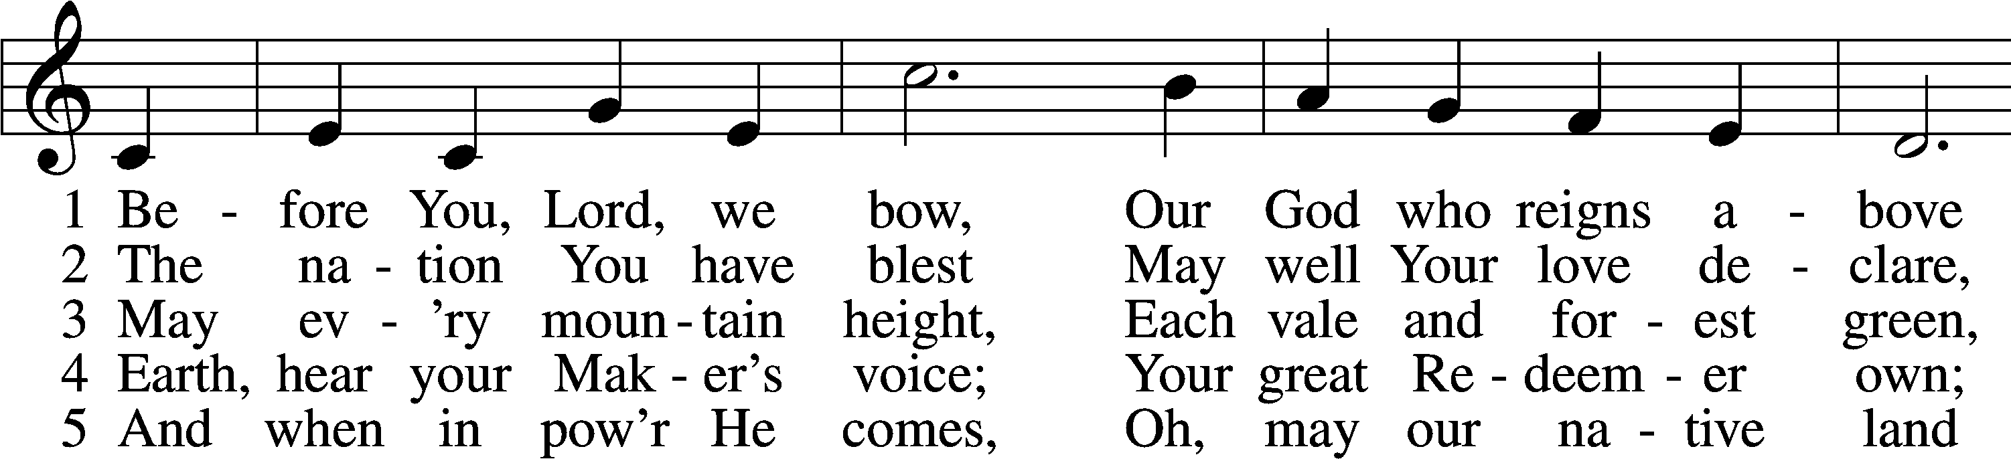
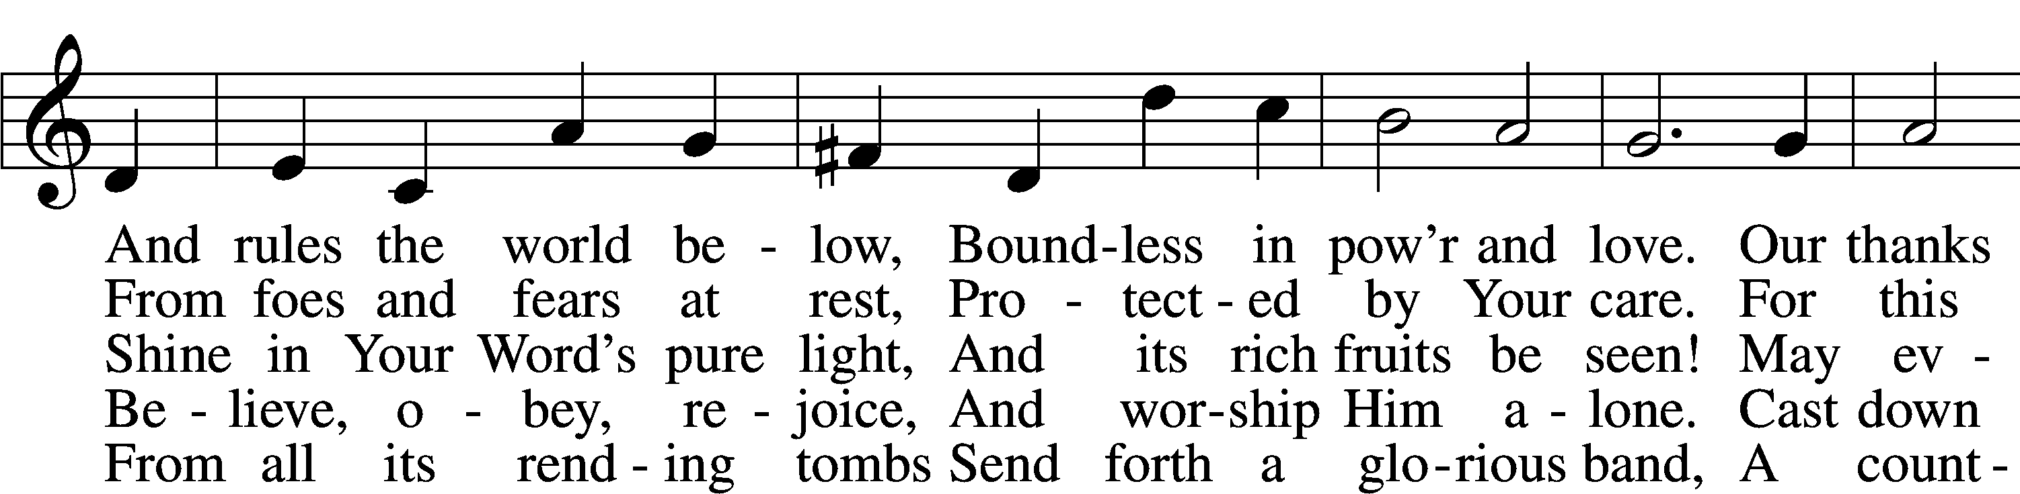
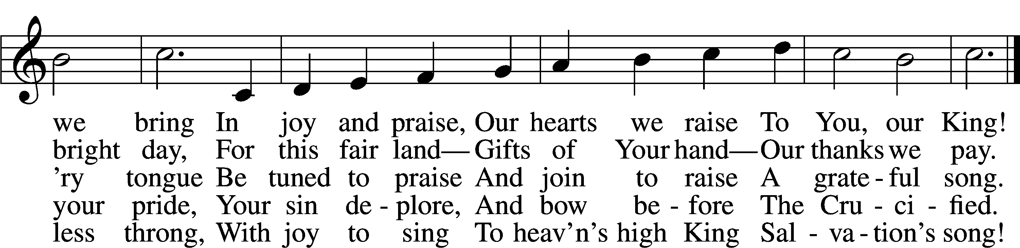
Text: Francis Scott Key, 1779–1843, alt.
Tune: John Darwall, 1731–89
Text and tune: Public domain

ANNOUNCEMENTS and SENDING WORDS
P We go to live for Jesus!
C We go to share His love!

Acknowledgments
Unless otherwise indicated, Scripture quotations are from the ESV® Bible (The Holy Bible, English Standard Version®), copyright © 2001 by Crossway, a publishing ministry of Good News Publishers. Used by permission. All rights reserved. Created by Lutheran Service Builde

